PC-1 Tracker – Technical Architecture & Implementation Guide
Version: 1.1
Date: September 2025
Author: Nasir Ali Kazmi
Status: Final Draft

Table of Contents
- Introduction
1.1. Project Overview
1.2. Document Purpose & Audience
- System Architecture
2.1. Architectural Overview
2.2. Technology Stack
2.3. Ingestion Pipeline
- Data Model & Database Schema
3.1. Entity-Relationship Diagram (ERD)
3.2. Core Model Definitions
- Core Module Deep Dive
4.1. Ingestion Services (ExcelIngestionService, WorkbookProcessor)
4.2. Data Models & Validation (models.py)
4.3. REST API Layer (views.py, serializers.py)
4.4. Utilities & Asynchronous Processing (tasks.py, signals.py)
- Admin Interface & Reporting
5.1. Custom Django Admin
5.2. Data Export & Reporting
- Deployment & Configuration
6.1. Dockerized Deployment
- Security, Audit, & Compliance
7.1. Security Measures
7.2. Audit Trails
7.3. Data Integrity
- Future Enhancements
- Appendix
9.1. Sample API Payloads
9.2. Admin Interface Screenshots

1. Introduction

1.1. Project Overview
The PC-1 Tracker is a modular, audit-ready web application designed to automate the ingestion, validation, and management of structured field data submissions (primarily Excel). It enforces data integrity through schema validation, provides granular row-level tracking for donor compliance, and enables dynamic filtering and reporting for MEL teams and government stakeholders. The system ensures full traceability from the original file upload to the final exported report.

1.2. Document Purpose & Audience
This document provides a comprehensive technical reference for:
- Developers needing to understand, maintain, or extend the codebase.
- System Integrators connecting the PC-1 Tracker to other MEL platforms.
- Technical Stakeholders (e.g., DevOps, IT Managers) responsible for deployment and infrastructure.
It details the system's architecture, data models, API endpoints, and key workflows to facilitate development, auditing, and operational oversight.

2. System Architecture

2.1. Architectural Overview
The system employs a modular Django backend following the Model-View-Template (MVT) pattern, with a clear separation of concerns:
- Ingestion Layer: Handles file upload, parsing, and data validation.
- Data Layer: Manages structured storage in PostgreSQL with Django ORM.
- API Layer: Exposes RESTful endpoints for all operations via Django REST Framework (DRF).
- Task Layer: Processes long-running jobs (file processing) asynchronously using Celery.
The backend currently serves a customized Django Admin interface and a headless REST API, prepped for integration with a modern frontend framework like React or Vue.js.

2.2. Technology Stack
Layer | Technology / Purpose
Backend Framework | Django (Python 3.x)
Database | PostgreSQL (v12+)
API Layer | Django REST Framework (DRF)
File Processing | Pandas (DataFrames), Openpyxl (Excel manipulation), Tabula-py (PDF)
Task Queue | Celery with Redis Broker & Result Backend
Caching | Redis
Storage | Local filesystem (designed for easy migration to S3/Azure Blob Storage)
Containerization | Docker, Docker-Compose
Web Server | Gunicorn

2.3. Ingestion Pipeline
The end-to-end flow for processing a file is automated and resilient, designed to handle large datasets without blocking user requests.
Diagram
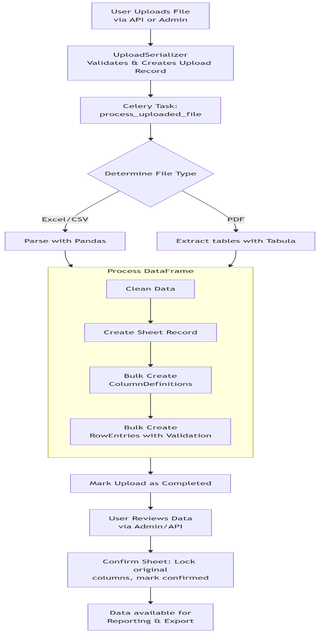

3. Data Model & Database Schema

3.1. Entity-Relationship Diagram (ERD)
The schema is designed for full auditability, tracking the lifecycle of every data point from its source file to its current state.
Diagram
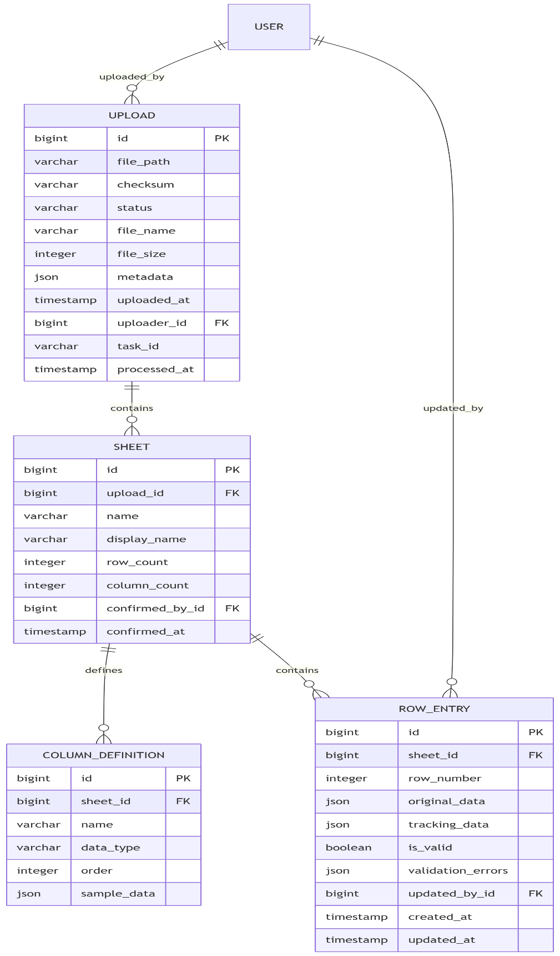

3.2. Core Model Definitions
- Upload: The central record for any file submission. Tracks lifecycle (status), origin (uploader), integrity (checksum), and processing metadata (task_id, processed_at). The metadata JSONField allows for flexible storage of source system, version numbers, or other contextual info.
- Sheet: Represents a single worksheet within an uploaded file. Links to its parent Upload and stores basic metrics. The confirmed_by and confirmed_at fields are set after a user review, triggering the file-locking process.
- ColumnDefinition: Stores the inferred schema metadata for each column in a Sheet (name, data type, position, sample data). This is critical for driving dynamic validation, reporting, and frontend rendering of data tables.
- RowEntry: The core data entity. original_data holds the immutable raw values from the file. tracking_data holds editable verification metadata (e.g., Verified_By, Functional). The validation status is captured in is_valid and validation_errors. The updated_by field provides a clear audit trail for every change.

4. Core Module Deep Dive

4.1. Ingestion Services
- ExcelIngestionService: A high-level orchestrator that manages the entire ingestion process. It coordinates between file handling (saving, checksum generation), parsing via the WorkbookProcessor, model persistence (creating Upload, Sheet, RowEntry records), and error handling.
- WorkbookProcessor: A dedicated utility class that leverages pandas and openpyxl to parse Excel workbooks. It handles sheet iteration, data cleaning (removing empty rows/columns), type inference, and converts each sheet into a clean, structured JSON format for downstream processing.

4.2. Data Models & Validation (models.py)
Key functionalities encapsulated in the models:
- Centralized Validation: A TRACKING_VALIDATORS dictionary (e.g., {'Functional': bool, 'Quality_Score': lambda x: 0 <= x <= 100}) provides a single source of truth for tracking_data validation. This is enforced within the RowEntry.clean() method.
- Automatic Auditability: Django's auto_now_add and auto_now handle timestamps. A pre_save signal (in signals.py) automatically sets the updated_by field to the current user on every row edit, ensuring attribution without manual intervention.
- Performance Optimizations: The use of CheckConstraint (e.g., file_size >= 0) ensures data sanity. Database indexes are strategically applied to key fields like status (Upload), upload_id (Sheet), and row_number (RowEntry) to optimize query performance for large datasets.

4.3. REST API Layer (views.py, serializers.py)
- ViewSets: Provide RESTful endpoints with robust functionality.
  - UploadViewSet: Standard CRUD + custom actions: excel (upload), reprocess (async), preview (get sample data), summary (get stats).
  - SheetViewSet: Read-only list/retrieve + stats action for sheet-level aggregations.
  - RowEntryViewSet: CRUD with extensive filtering on all fields. Includes an export action to download filtered rows as CSV.
- Serializers: Handle complex validation and transformation logic.
  - UploadSerializer/UploadDetailSerializer: Handle file upload, checksum calculation, and nested representation of related sheets.
  - RowEntrySerializer: Performs validation on tracking_data using the TRACKING_VALIDATORS and manages audit field writing.
  - ExcelUploadSerializer: The primary entry point for API uploads, handling the initial file save and triggering the async processing task.

4.4. Utilities & Asynchronous Processing
- tasks.py: Contains the core Celery task process_uploaded_file. It is designed for resilience (max_retries=3) and performance, using batched database operations (bulk_create) to efficiently ingest thousands of rows.
- signals.py: Uses a Django pre_save signal to automatically attribute the updated_by field on the RowEntry model to the current user, a crucial feature for audit compliance.
- file_utils.py & excel_processor.py: Contain low-level utilities for safe file handling, checksum generation (hashlib), and Excel manipulation (locking cells with openpyxl to protect original data after confirmation).

5. Admin Interface & Reporting

5.1. Custom Django Admin
The Django Admin is heavily customized to be a primary user interface, not just a simple backend tool:
- Visual Feedback: Color-coded status badges for uploads (pending, processing, completed, failed) and row validity (valid, invalid).
- Inline Previews: Administrators can view related ColumnDefinitions and sample RowEntries directly within the Upload and Sheet admin change pages.
- Administrative Actions: Actions like "Reprocess Upload" are added to retry failed ingestions or reprocess files after a code update.
- Advanced Filtering & Search: The admin interface allows filtering by any key model field and searching across text-based JSONFields in RowEntry.

5.2. Data Export & Reporting
- CSV Export: The RowEntryViewSet provides an export action that generates a CSV file of filtered data, including both original_data and tracking_data, suitable for offline analysis in Excel or other tools.
- Programmatic Reporting: The API endpoints (summary, stats) provide JSON-structured aggregates (counts, sums, averages, validity percentages) that can be consumed by frontend applications to build dynamic dashboards and visualizations.

6. Deployment & Configuration

6.1. Dockerized Deployment
The system is designed for simplified, consistent deployment using Docker containers:
- docker-compose.yml defines four services:
  - db: PostgreSQL database.
  - redis: Broker and result backend for Celery.
  - web: Django application served by Gunicorn.
  - celery-worker: Celery worker process for handling async tasks.
- Configuration: All sensitive and environment-specific parameters (database URL, secret keys, debug flags) are managed through environment variables, adhering to the 12-factor app methodology.

7. Security, Audit, & Compliance

7.1. Security Measures
- Authentication: Access to the Django Admin and REST API is restricted to authenticated users via Django's built-in session-based authentication system. The API can be easily extended with Token or JWT authentication.
- Authorization: Permissions are enforced at the view level. The RowEntryViewSet filters querysets to only include records from uploads owned by the current user, ensuring data isolation.

7.2. Audit Trails
- Full Attribution: Every change to a RowEntry is attributed to a user (updated_by) and timestamped (updated_at). The Upload model tracks the original uploader.
- File Integrity: The MD5 checksum of the original file is stored, allowing for verification that the source data has not been tampered with after upload.
- Django Admin History: The admin interface logs all changes made through it, providing an additional layer of audit logging.

7.3. Data Integrity
- Immutability by Design: The original_data JSONField is immutable after ingestion. The confirmed sheet process physically locks the original Excel columns, preventing modifications.
- Validation: Data quality is enforced through a two-layer validation system: schema validation during ingestion and custom validation rules on the tracking_data field.

8. Future Enhancements
The architecture is designed to accommodate the following planned enhancements:
- 1. Dedicated Frontend Application: Develop a modern React/Vue.js SPA to replace Django Admin for day-to-day user interactions, improving UX and responsiveness.
- 2. Enhanced Reporting Dashboard: Build interactive charts, maps, and pivot tables on top of the existing API to provide deeper insights into the data.
- 3. Advanced Role-Based Access Control (RBAC): Implement groups and permissions for fine-grained control over what different user roles (e.g., Field Officer, MEL Manager, Donor) can see and do.
- 4. System Integration APIs: Develop standardized REST/JSON APIs for bidirectional synchronization with other national MEL platforms or DHIS2.
- 5. Real-time Notifications: Integrate with email or SMS services to notify users of upload processing results or data validation errors.

9. Appendix

9.1. Sample API Payloads
Request: POST /api/uploads/excel/
bash
curl -X POST -H "Content-Type: multipart/form-data" -F "file=@/path/to/data.xlsx" http://localhost:8000/api/uploads/excel/
Response: 201 Created
json
{
"id": 42,
"file_name": "data.xlsx",
"status": "pending",
"uploaded_at": "2025-09-05T12:00:00Z",
"uploader_name": "nasir",
"file_url": "/media/uploads/2025/09/05/data.xlsx"
}
Request: GET /api/uploads/42/summary/
Response: 200 OK
json
{
"upload_id": 42,
"total_rows": 1500,
"valid_rows": 1450,
"invalid_rows": 50,
"validity_percentage": 96.67
}

9.2. Admin Interface Screenshots
(This section would contain annotated screenshots showing:)
- The main upload list view with status badges.
- The detailed upload admin page with inline sheet previews.

